Rudolstadt, Germany, June 6, 2014

The story of smartcel™ sensitive: How a cellulose fiber with zinc turns textiles into real skin care products!

How did the idea to develop the smartcel™ sensitive-fiber arise?

smartfiber AG was repeatedly confronted by its customers with one requirement from all sectors of the textile industry: “We need a fiber with an antibacterial effect that is simultaneously gentle and caring to the skin.“ No sooner said than done. In cooperation with the Thuringian Institute of Textile and Plastics Research (TITK) a functional fiber with the active substance zinc was developed. The advantage: Zinc is a natural element, which has an antibacterial effect and also positive influence on the human body and therefore on the skin.

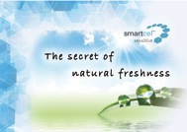
What is so extraordinary about smartcel™ sensitive?

The smartcel™ sensitive-fiber uses the skin caring effect of the essential trace element zinc. Through the application of a high-quality, natural and even medically approved zinc oxide, this high-tech fiber combines regenerative and skin caring effects with hygienic properties.

Our skin benefits from that. As the protective shield of the body, our skin receives support and care through textiles with smartcel™ sensitive. In everyday life, nothing is in such close contact with our skin as clothing, home textiles and underwear. The smartcel™ sensitive fiber uses this combination by integrating the best of the true elixir of life zinc: the cosmetic effect for our skin.

The production process of this natural fiber is done without use of nanotechnology and aggressive chemicals. smartcel™ sensitive is certified by Oeko-Tex® standard 100, product class 1 (for baby products). Moreover the innovative and patented fiber technology is embedding the trace element zinc permanently, i.e. the properties remain effective for the whole life time of the product. The smartcel™ sensitive fiber is made of a biogenic raw material, which is environmentally friendly, sustainable and 100% biodegradable. You skin will thank you!

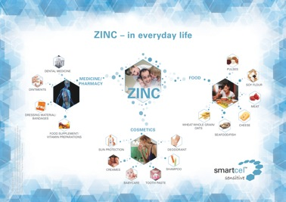

What are the advantages of zinc for human beings?

Zinc exists worldwide in the earth crust, especially in ores. It is vital for humans. Like almost no other nutrient, zinc has a big impact on our wellbeing. After iron, zinc is the most frequent trace element within the human body. Zinc provides for a healthy growth in humans, animals and plants. It is omnipresent within the body and of crucial relevance for the core functions of the organism. It strengthens the immune system and the body‘s defences but also sensory functions and fertility.

In nutrition it takes on an important role as well. As an essential component of over 100 enzymes, zinc contributes to the digestion and utilization of fats, proteins and carbohydrates and is closely involved in energy production and prevents symptoms of deficiency in the long term. Animal source foods like meat, fish, seafood and cheese, but also oat flakes and wheat whole grain flour are high in zinc.

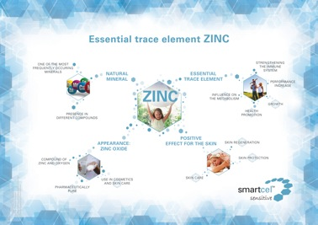

In which form is zinc inserted into the smartcel™ sensitive-fiber?

smartcel™ sensitive contains pharma 4 grade zinc white. This pharmaceutically pure zinc oxide produced from metallic zinc meets DAB 10 purity requirements and other international regulations for the preparation of pharmaceuticals. We use this zinc oxide daily – in sun blockers as protection from harmful UV radiation, in ointments, powder, in high quality face creams, baby care products and cosmetic products. In all these products zinc oxide supports the natural processes of the skin, fosters the wound healing and fights skin inflammation.

The smartcel™ sensitive fiber uses the skin caring effect of zinc oxide for textiles with a soft, regenerative effect. Integrated into the fiber, zinc oxide, as a component of skin-building enzymes, acts directly on the skin and does not have to be transported to the skin first. Thus, smartcel™ sensitive has the secret of natural freshness.

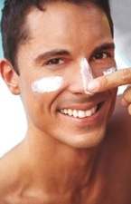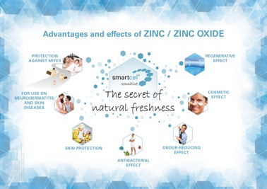

For which textiles is smartcel™ sensitive especially suited?

During the further development of smartcel™ sensitive, smartfiber AG followed the customers requirements of all textile sectors. Therefore, the zinc fiber is ideally suited for textiles of all kinds. smartcel™ sensitive is combinable with all common fiber types like synthetics, cotton and many others. Furthermore, the fiber remains effective even in wool blends. To guarantee the effect, only 10 % of the smartcel™ sensitive -fibers are needed in the end product. The fiber can be integrated without any difficulty in all textile standard processes (e.g. dyeing and finishing).

In addition to an enhancement of the wear comfort and the protection from stress factors or similar environmental influences, the revitalizing properties of this fiber are helpful for all people. This includes business-, work-, sports- and leisure wear, baby- and children’s clothing, underwear and socks.

smartcel™ sensitive is also suitable for the use in home textiles like bedding, bed linen, mattresses, and towels. Test results of the renowned Hohenstein Institutes confirm the effect of smartcel™ sensitive. They prove a transfer of zinc ions from the filling of duvets with smartcel™ sensitive – which are not in direct contact with the skin – onto the skin of the sleeping person where they develop their positive, skin-regenerative effect.

The whole power of the fiber shows its strength in work clothing and medical textiles: its cosmetic and caring effect in combination with antibacterial efficiency – thanks to the high content of zinc oxide. smartcel™ sensitive‘s strong bacteriostatic efficacy against antibiotic-resistant germs (MRSA) makes it an ideal choice for medical applications like surgical clothing and clothing for medical professionals as well as hospital bed sheets and curtains. Textiles with smartcel™ sensitive have been also clinically tested to improve quality of life for allergy sufferers and people with neurodermatitis and sensitive skin. smartcel™ sensitive is also ideally applicable in dressing materials and plasters. The fiber permits quicker skin regeneration and complication-free wound healing.

For these reasons, a lot of providers of the sectors fashion, clothing, home textiles and medical textiles already rely on smartcel™ sensitive.

Has the effect of smartcel™ sensitive been proven?

The efficiency of smartcel™ sensitive-Faser was tested with positive results by several independent institutes – like the Hohenstein Institutes or the University Clinic of Jena for Dermatology and Dermatologic Allergology. The certificates and test reports are available in the download area on www.smartfiber.de.

What company is behind the fiber?

The smartfiber AG, seated in Rudolstadt (Thuringia), was founded in 2005. The company develops and markets lyocell fibers which are using natural wood pulp with different functionalities for the international market. The technology is based on research and development work of the renowned Thuringian Institute for Textile and Plastics Research (TITK) in Rudolstadt, Germany. smartfiber succeeded in incorporating natural additives permanently into cellulosic fibers known as lyocell with positive effects on skin and body. The hightech-fibers with the internationally protected trademarks SeaCell™ and smartcel™ sensitive are today the basis for innovative products in the textile and nonwoven sector. On this account, smartfiber AG sets greatest value upon quality controls implemented by independent institutes and laboratories. To ensure the premium processing of the fibers, the company cooperates with selected international production partners in the entire textile processing industry. Since the end of 2011, Lenzing AG, the world market leader for industrially produced cellulose fibers, exclusively produces the lyocell fibers developed by smartfiber. The fiber technology received several awards, among others the famous “Deutscher Innovationspreis” (German Innovation Prize) in 2010. For further information please go to www.smartfiber.de, www.facebook.com/smartfiberAG, www.twitter.com/smartfiberNews, www.youtube.com/user/smartfiberAG.

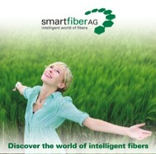
Where can I get more information about smartfiber AG and smartcel™ sensitive?

More information about smartfiber AG:

Company website
www.smartfiber.de

Facebook
www.facebook.com/smartfiberAG

Twitter
www.twitter.com/smartfiberNews

Youtube
www.youtube.com/user/smartfiberAG

More information about smartcel™ sensitive:

Facebook
www.facebook.com/smartcelsensitive

Twitter
www.twitter.com/smartcelEn

Youtube
www.youtube.com/user/smartcelsensitive

